New NAM Logo

Information about the New NAM Logo

**ZAYDAN NAUFAL ALFARIZ**

Introduction

This logo was made in order to respect the previous people in the NAM and showcases the lastest contribution in the NAM, especially RHW & Project Symphony. This logo is the first time logo since the logo vote is over. This logo has many differences compared to previous NAM logo. But, the orange color still retained & more polished into gradients, especially in Color 1024px version. This logo can used on mobile devices properly, not like previous logo. Originally, this logo will be exported to the SVG to support responsive logo design principle. But, some obstacles made this effort failed. If you think SVG support is important, you can convert it into SVGs with tools like GIMP (you need to vectorize the pixel).

This logo isn’t perfect, however. Some points like px count on the PNG-version of the logo isn’t perfect. If you have suggestions, just reply my topic on SC4Devotion & Simtropolis.

Logo Description



* **Gradients** means NAM Team always moving forward. However, NAM Team also view on the back to check the quality and respect the formers.
* **Two Highways** means NAM has more than one way to do it. For example, you can create a highway ramp by drawing a pattern.
* **The roundabout** mean NAM (and the Team) must unified. This is also showcases the lastest contribution to the NAM, especially in Project Symphony.
* **Gold color** mean NAM Team is a big team that create big mods. This is mean NAM Team has energies to make big mods.
* **The recommended spacing** between the logo and logotype is 56px with the logotype is centered.
* **The used font** is URW Gothic L, Semi Bold. For first text, I’m using the font with 200pt size and without letter-spacing. For second text, I’m using the font with 200pt size and with 60px letter-spacing. For third text, I’m using the font with 330pt and with 100px letter-spacing.
* **The color code** used in the highway 1 is **#f4c831ff**. Highway 2 use the **#d0980cff**. And, roundabout use the **#ecd450ff**.
* **This logo** also includes 3 raw files used to modify the logo. The logo itself is licensed with Creative Commons 4.0 Non-Commercial. You may modify the logo, but can’t use it on commercial material. You may create & distribute derivatives but you should credit me as the creator. More info is at **creativecommons.org/use-remix**.

Versions

This logo has 3 versions:

* **Full color** is suited for white & black background because it has gradients. Can be founded on **Output/Full Color**.
* **Grayscale** is suited for white & black background because it has some gradients inside. Can be founded on **Output/Grayscale**.
* 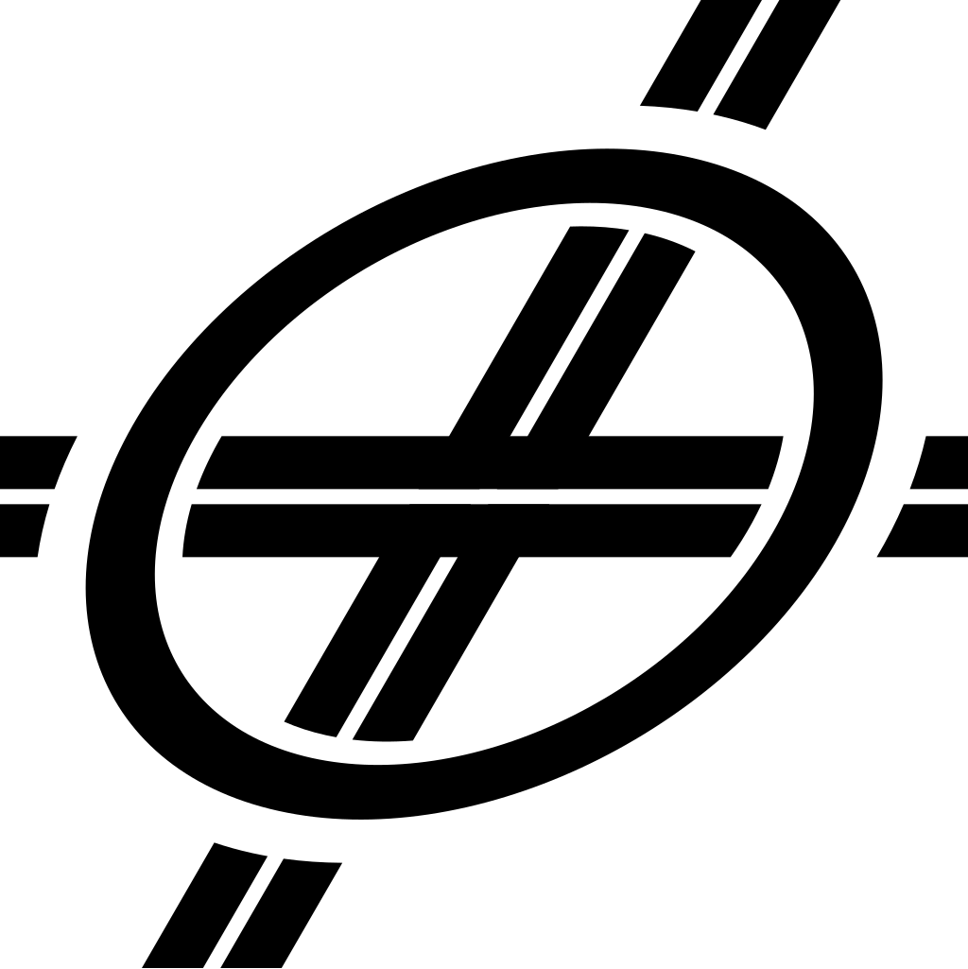**Single color** is suited for any colors. Can be founded on **Output/Single Color**.

THANK YOU

If you have suggestion, just reply my topic on SC4Devotion & Simtropolis.